Name: Anshum Kumar
Student ID: 22332830
Module title and code: Software Engineering 24SPRHW
Project title: Fire and Security Alarm Monitoring System (FASAM)

Introduction

The Fire and Security Alarm Monitoring System (FASAM) is an automated alarm and Security system in a large building that monitors and controls all fire and security alarms across several zones. The system provides automated responses to detect fire alarms using sensors, including false alarms. It has the capability to alert a central manned control area, alert emergency services, provide alarm notification, and evacuation instructions. Furthermore, the security system provides further protection in case of fire such as automatic door closures, sprinkler systems, and electrical equipment shutdown.
The report will provide detailed information and analysis of the FASAM system by providing clear, detailed functional and non-functional requirements, partial specification that outlines the key features and functionalities of the system, architectural design using the UML Modelling Technique, Prototype for the Proposed System User Interface and Requirements Validation and Management Strategy. Therefore, the report will provide a detailed solution of a system that solves this real time, large scale and safety concerning issue.

Functional Requirements:

ID | Title | Detailed Explanation | Priority
FR-1.1 | Sensor Detection | The system must be able to detect and monitor fire, smoke, and heat hazards using multiple sensors in every zone of the building. | High
FR-1.2 | Sensor Detection | The system must analyse inputs from all sensors to confirm a fire incident before reporting. It must be able to measure the intensity of smoke and fire. | High
FR-1.3 | Sensor  Detection | The system must perform automatic diagnostics every day to confirm if the sensors are operational and working | High
FR-1.4 | Sensor  Detection | The system must alert operators if any sensors are not working faulty and not operational. | High
FR-2 | Alarm monitoring | The System must continuously monitor all fire and security alarms and sensors in every zone of the building and keep providing real time data to operators. | High
FR-3.1 | CCA Alerting | System must notify the Central Control Area about any fire and smoke incidents and show them precise location in the building. | High
FR-3.2 | CCA Alerting | The system must notify the Central Control Area of any unconfirmed false fire and smoke detection on sensors and prompt operators to take action. | Medium
FR-4 | Alert emergency services | If the Central Control Area is unmanned, the system must be able to alert emergency services. It must call emergency services; automated voice must mention location of building and reason for calling emergency services. System must share the location with emergency services. | High
FR-5.1 | False alarm detection and prevention | The system must detect false alarms, and it must not call emergency services before confirming if the alarm is genuine using sensors mentioned in FR-1. | High
FR-5.2 | False alarm detection and prevention | The system must allow authorized operators to stop false alarms and log information about alarm cancellations. Ex: Time and reason. | High
FR-6 | Sprinkler activation and electrical shutdown | The system must activate the sprinkler system and turn off the electrical equipment only after detecting and confirming no people are present in the room in case of fire and smoke. | High
FR-7 | Direction indicators illumination | In a confirmed fire incident, the system must illuminate direction indicators to the route to the nearest exit. | High
FR-8 | Audible evacuation warning | By confirming the alarm, the system must emit an audible warning sound to alert the people in the rooms to evacuate the building. It must do it until the sound is stopped manually by emergency service personnel or operators | High
FR-9.1 | Door lock | When the alarm is confirmed, the system must automatically lock specific doors that are designed to be closed to allow full isolation of a zone from fire and smoke. | High
FR-9.2 | Door lock | System must allow operators to manually close their chosen doors in any zone of the building. This way the system must allow operators to choose and decide which zones of building they need to completely isolate from rest of the building by locking doors
FR-10 | Display data | The system must display real-time data and status of all fire and security alarms and sensors. | High
FR-11.1 | Data Storage | The system must record all alarm activities, sensor data, sprinkler system, electrical shutdown system and contacts being made to emergency services and save the records. The system must save the details mentioned above in storage servers in the building. | High
FR-11.2 | Data Storage | The system must send and save data on online cloud services. | Medium
FR-12 | Adding information | The system must allow operators to log in information about fire incidents and false alarms. The system should save and keep this information secure. (Sygma, 2024) | High
FR-13 | Display data | The system must clearly display the precise location of the fire and smoke in the building. | High
FR-14.1 | Maintenance mode | System must be able to enter in a maintenance mode to assist operators to test fire, smoke, security systems and sensors manually | High
FR-14.2 | Maintenance mode | System must be able to record all the data gathered during maintenance assessment and create a detailed report of results. (Sygma, 2024) | High
FR-14.3 | Maintenance mode | The system should prompt operators to conduct fire risk maintenance and assessment every 3 months. The system should automatically schedule maintenance service reminders. (Apollo, 2019) | Medium
FR-15 | System self-monitoring | System must be able to check its connection with internet and network; it must be able to alert operators if the network connection is unstable. | High
FR-15.2 | System self-monitoring | System must test and check if its hardware components are working and report any performance issues | High
FR-16 | Scalability and expandability | System must be scalable, if new sensors and zones need to be added and configured, the system must be able to do it with minimum configuration. | High
FR-17 | Accessibility | System can be used in multiple languages, allowing operators to choose their preferred language. | Low
FR-18 | Security | It should be possible to create account credentials with login and password for operators. System must prompt operators to log in. | Medium
FR-18.2 | Security | In case of fire and smoke emergency, the system must show location of fire and smoke incident without the need of logging in, system must also allow an option to contact emergency services even without logging in. | High
FR-18.3 | Security | The system must keep data sent and received to emergency services secure and protected. (GOV UK, 2018) | High
FR-19 | Power Saving | System can turn on its power saving mode to save energy. | Low

Non-Functional requirements:

ID | Title | Detailed explanation | Target
NF-1.1 | System Performance | The system must be very fast, it should not slow down, it must respond to alarms in less than 1 second when smoke and fire is detected. | < 1 Second
NF-1.2 | System Performance | Operators must be able to use the system interface without any problems, errors and issues. The system’s response time must be very fast. | Instant response time for users.
NF-2 | System accuracy | System needs to be accurate to detect fire and smoke, the system must be reliable. Regular maintenance ensures that system’s accuracy remains high. (Pulsar Vertex, 2024) | High Accuracy
NF-3 | Safety Standards and regulations | The system must meet International and UK alarm systems and fire prevention laws and standards, it must pass the tests conducted to confirm the system meets these requirements. The alarms must be fit by using and measuring correct measurements. | Must meet regulations, standards and laws set by UK government.
NF-4 | Maintainability | System must be regularly updated and fixed regularly in upcoming version cycles. | Regular updates at least every 6 months.
NF-4.2 | Maintainability | Feedback can be taken from users about the system and it can be used to improve the system in next updates | Regular feedback and improvement.
NF-5 | Security | The system must be secure; it must meet data protection regulations set by the UK government. The system must encrypt and decrypt data. (GOV UK, 2018) | Data protection and encryption
NF-6 | Data Backup | System must send the data to an online cloud storage so that all the data can be recovered in case of hardware failure. This must be conducted every week. (Sygma, 2024) | Cloud backup every week.
NF-7 | System Expandability | System must be able to work for multiple large organizations with large zones in the building. System must also work and meet the demands for organizations with multiple building | System must work for 100 organizations with 2 or more buildings and large zones.
NF-8 | System Availability | System must be available and active 100% of times ensuring that it monitors all fire and smoke activity through sensors | 100% active always.
NF-9 | Usability | System should be easy to use and should provide clear instructions to operators providing them step by step guide of its functionalities | Easy to use.
NF-10 | Sustainability | System can enter power saving mode during the time when sensors are inactive and have not detected any fire and smoke incidents to save energy when operators are available in Central Manned Area. However, it must not be in low power saving mode when Central Unmanned Area is not supervised by operators. | Low power saving mode can reduce at least 10% of power consumption.
NF-11 | System Configuration | System must be able to work on multiple operating systems. It must work and must be supported on Windows, Linux and Mac. | Must work on Windows, Linux and Mac devices.

Partial Specification
Key features and functionalities of the system:

Sensor Detection System:

Collect data from dedicated sensors designed to detect smoke and heat. Collects precise heat, fire and smoke readings. It can distinguish between air and smoke. It can measure the intensity of smoke, fire and heat. It sends these readings to the System’s software. All sensors are connected to the internet network system of the organization. Sensors have a cable connection to the main power supply.
Alarm System:

Receives instructions from system’s software and alarm rings when it is instructed to perform this task by the software. Alarm system connected to the internet network system of the organization. The alarm system is connected to the main power supply.
Main Software System:

Manages all sensors and alarms in all zones of the building. It can collect and manage all the data. Instructs alarm system to react when smoke and fire are detected. The software system is automatic; however, it can also be managed by operators. Software systems can automatically call emergency services. The software system has the capabilities to perform full diagnostics and maintenance of alarm and sensors system. The software system must alert central control manned are in case of fire and smoke detection, it has the capability to perform electrical shutdown, activate sprinkler system, automatically lock doors and emit audible warnings along with illuminating direction indicators to the route to the nearest exit.

Software App:

Software app that displays all real time data. The app is used by operators in the Central Manned Control Area to monitor the entire building. Several functions can be performed through the app, such as stopping fire alarms to ring, contacting emergency services, conducting maintenance, record, add and maintain data. The app can automatically close doors to isolate zones from the rest of the building, however it will also allow operators to choose which doors to open and close during fire. The app will be a dashboard that will provide information about the activities detected by sensors in all parts of the building.

Data Storage:

Data collected by the system will be stored in physical data systems with large storage in the building. The data storage hard drives will be connected to the software system. Along with that, the data will also be stored in the online cloud service. The system will have the functionality to connect and integrate with the cloud services so that as soon as the data is collected, it is stored on the cloud. (IFSJ, 2024) The data will be in the form of Excel. Data must be protected and secure following the law set by the UK Government. (GOV UK, 2018)
Notification System: When the system confirms a fire and smoke incident, it will automatically send alerts to all devices connected in the building’s network. The system will also allow operators to send fire alerts manually.
Configuration: Operators will be able to add and remove sensors from the system. Operators will be able to configure security doors inside the buildings so that zones can be isolated from the rest of the building.

Self-Diagnostics: System has the ability perform self-tests and diagnostics, system should generate the report of these self-diagnostics clearly stating any vulnerabilities in the system, for example faulty sensors and alarms, electrical failures, network problems. (Sygma, 2024)
Communication system: System will be able to contact emergency services through its connection with cellular services used by mobiles. The system will call emergency services, and an automated voice will mention the location of the building along with the reason for calling emergency services. The system will be able to share its location with the emergency services.

Moscow method was used to prioritise certain requirements that are critically important for the system to develop successfully. “Must” requirements had extremely high priority, “should” is medium priority and “can” is low priority.
Reports from (Sygma, 2024) and (Apollo, 2019), highlighted the importance of legal requirements that the fire system assessment must be carried out every 3 months for safety. This was mentioned as an extremely high priority requirement in the documentation.
The data processed and stored by the system must be done securely and it must be conducted by following the law set by the UK Government (GOV UK, 2018). This has been mentioned clearly in the requirements document and it is a high priority requirement. Report by (IFSJ, 2024) has mentioned a secure cloud storage system where data can be saved and stored.

Use Case Diagrams
Automatic System Response
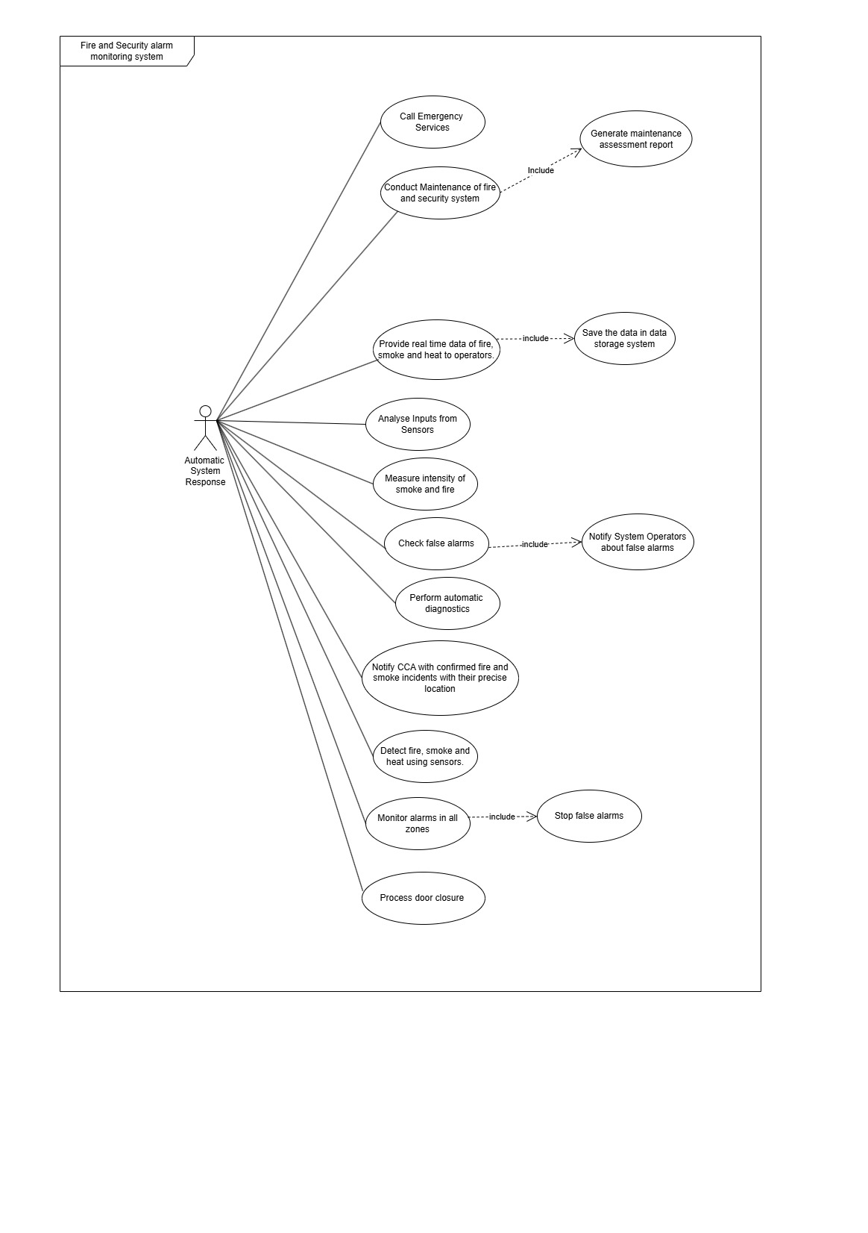:

This is the use case diagram for the main software system which conducts various tasks. The system detects and analyses inputs from sensors about smoke and heat. The system then notifies CCA about fire and smoke incidents with precise location and zone area. If no action is taken by CCA, which indicates that no one is present in the control area, then the system automatically contacts emergency services. The system has the capability to access and stop false fire and smoke alarms when it monitors all zones in the building, while alerting operators in CCA. Alerting CCA and stopping false alarms are important tasks which must be conducted, so this action has been included with a clear arrow sign. It can confirm this by measuring the intensity of smoke and fire. The system provides real-time data to operators by monitoring every zone using sensors. This data is saved on the storage system. The system can automatically isolate zones from the rest of the building using door closures, which are integrated into the security system. To ensure the system meets fire and safety regulations, the system can complete maintenance of fire and security systems. It generates an assessment report for operators to check, assess, and solve any vulnerabilities in the system.

System Operators:

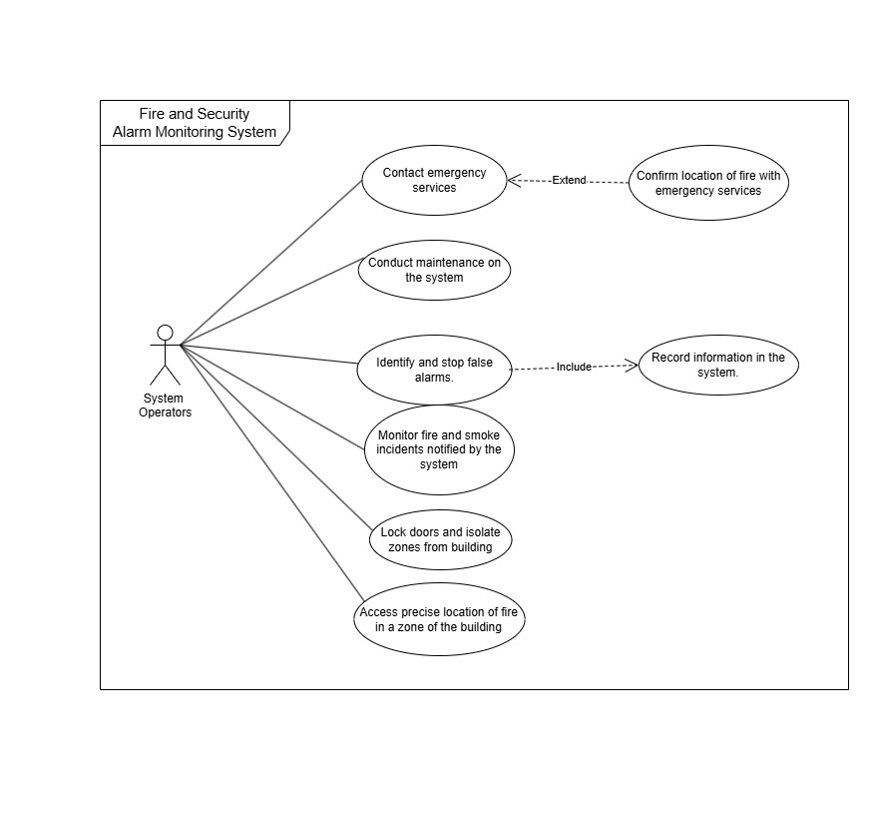
System operators will be able to contact emergency services, and they must confirm the location of the fire with them. They are also able to identify and stop false alarms and then they must further record and log in to the details to stop the alarm. Further of their main activities include conducting maintenance on the system, monitoring fire and smoke activities notified by the system, and accessing precise location of fire. One main functionality of system operators is that they can isolate zones from rest of the building during fire emergencies.

Fire services:
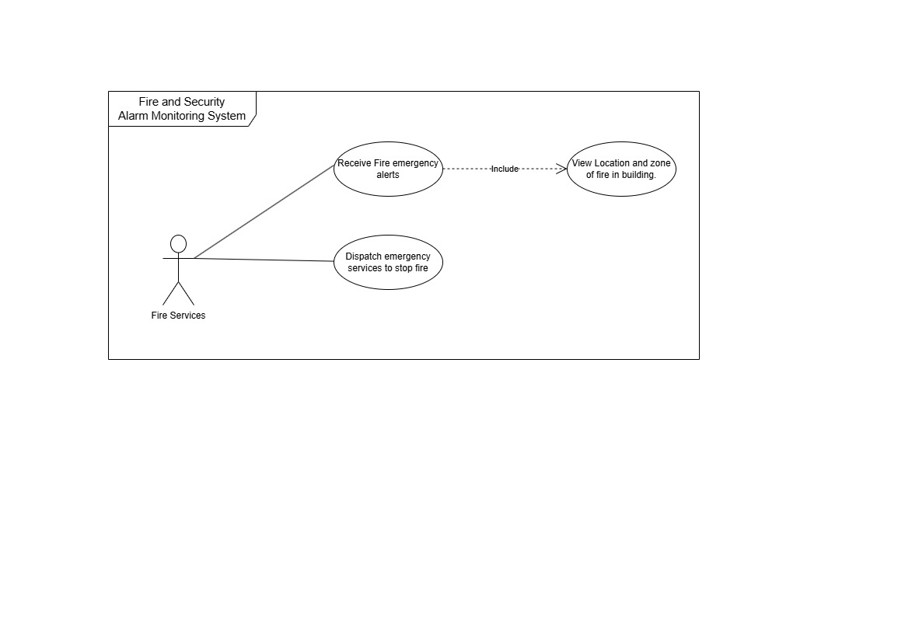
The role of fire services is simple, it's to receive fire emergency alerts from the fire system and they must be able to view the location and zone of fire in the building and that function has been included in the diagram. The use of “include” states that it is an important action and it must be completed.

Security Services:
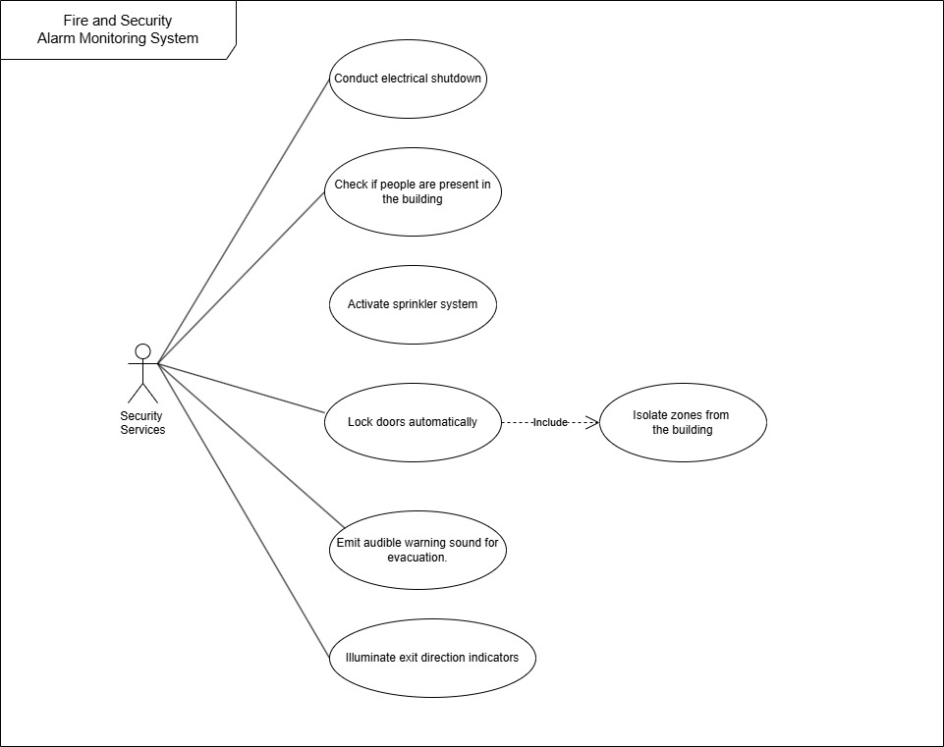

Security services' roles begin by checking whether people are present in a building. It identifies and makes an assessment. If people are not present, it will shut down electrical equipment and activate the sprinkler system to stop the fire. It will also automatically lock doors if no people are present in that room. However, if people are present, the system must not take these actions. The security system must always emit audible warning sound for evacuation, and it must illuminate exit direction indicators to help people evacuate the building.

Combined Use Case Diagram:

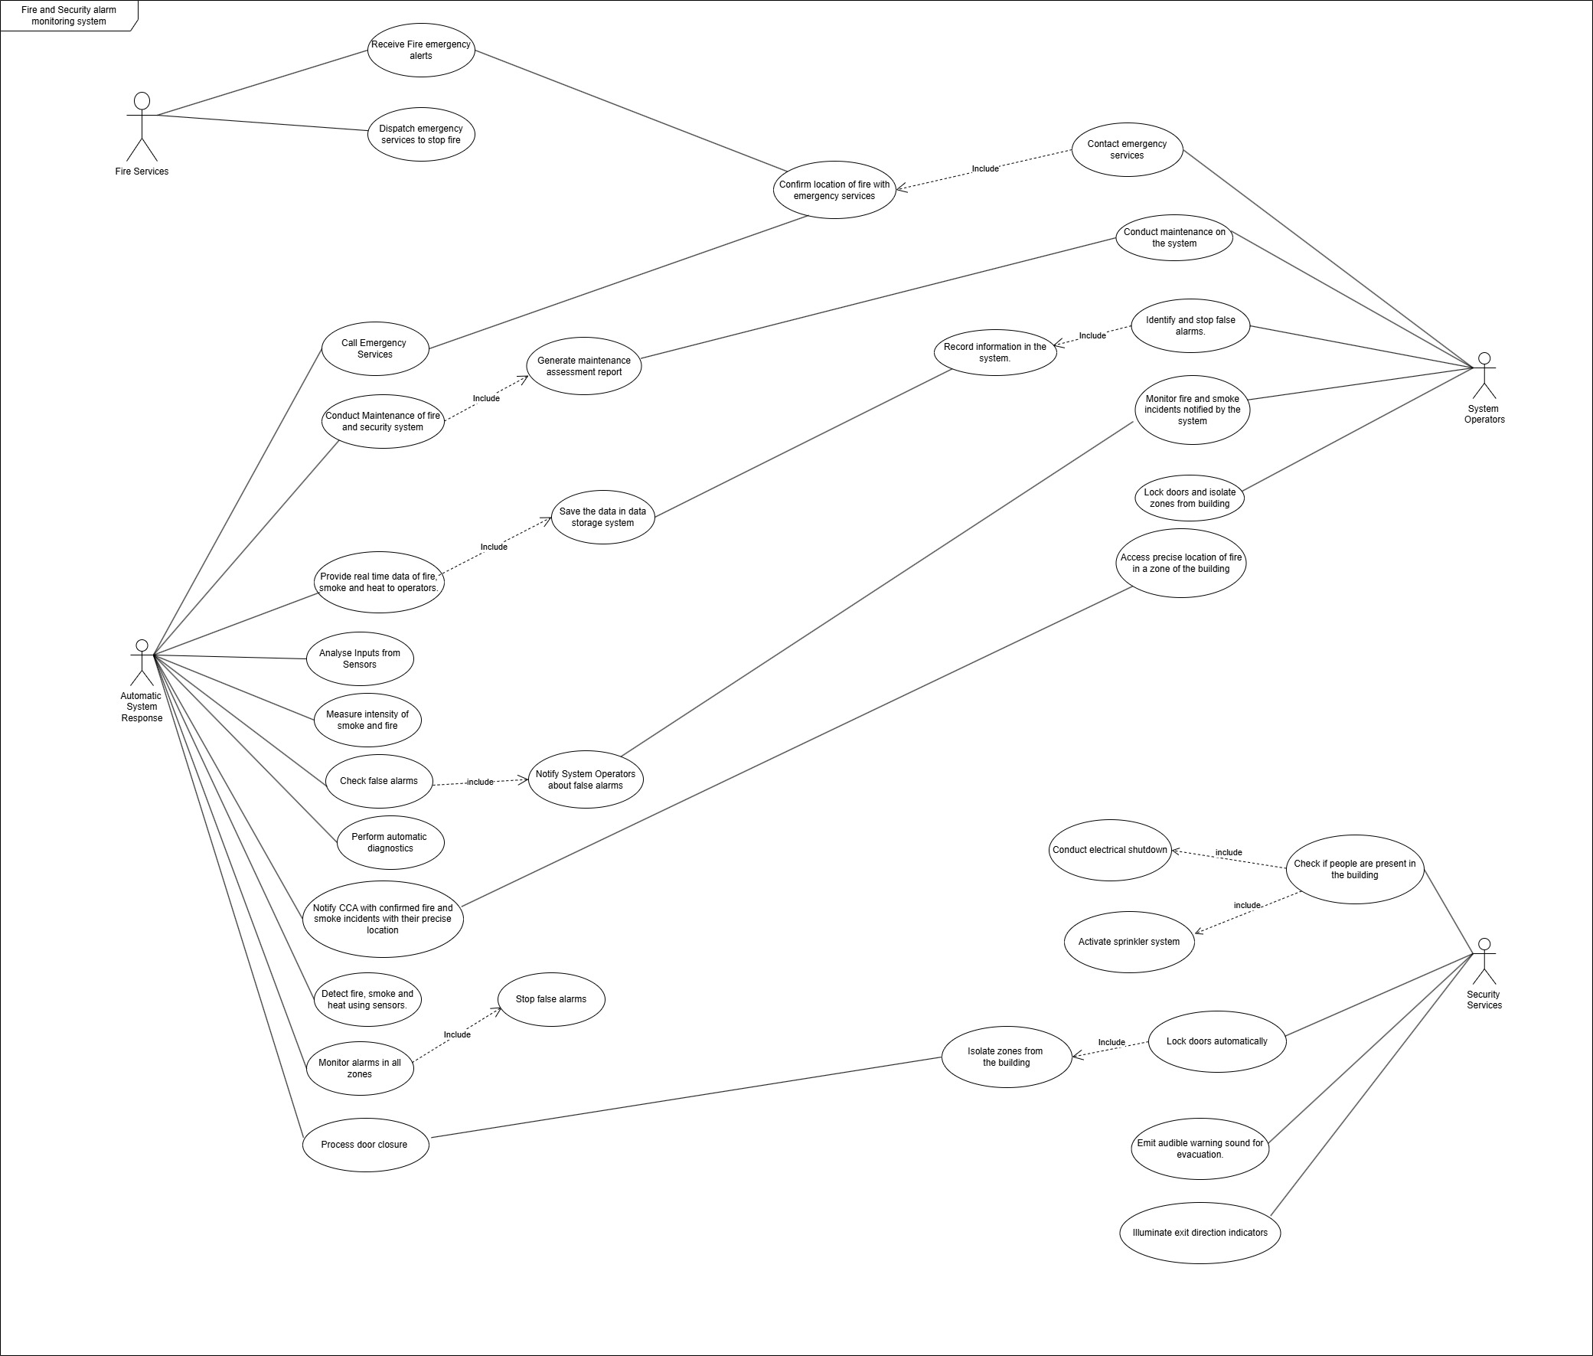
The 4 diagrams were then combined to make a fire and security alarm monitoring system. The emergency services receive fire emergency alerts from the system operators, the system operators confirm the location of fire with them, there is a clear link between emergency services and system operators on the action where location is shared.
Similarly, if the Central Control Area does not have an operator, the system automatically calls emergency services and confirms the location of fire incident, in this action, there is also a clear link between them.
When system operators’ maintenance on the system, they can access the assessment report generated by the system in this shared action between the system and operator.
Furthermore, both the system operators and the system can collect, record, and save data.
While the system monitors false alarms, it also notifies operators in the Central Control Area. The system operators can access the precise location of fire in the building when they are notified by the system.
The security service system must request lock doors to isolate zones from the rest of the building, and the main system must process the door closure.

Prototype for the software system:
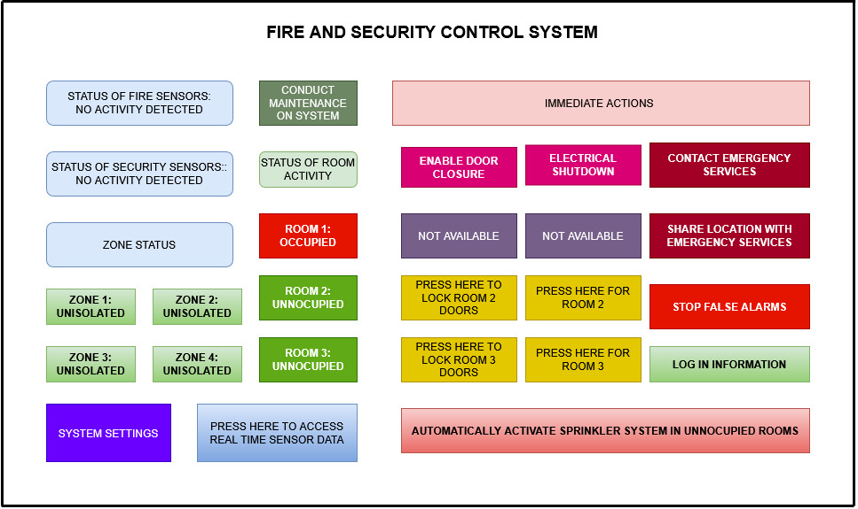
Left side displays status of sensors along with zone sensors. It allows user to track activities in each zone and rooms of the building. System settings can be changed such as language, power saving mode etc. Maintenance and fire assessment mentioned by report from (Sygma, 2024) can be conducted by pressing the maintenance button.
Right side has functionalities which will be used in critical emergency situations, it has option of contacting emergency services, sharing location, stopping false alarms, logging information, conducting electrical shutdowns in rooms where people are not present. This prototype ensures that the requirements mentioned above in the document will be achieved in the system’s software.
Requirements Validation and Management Strategy

The goal of the requirements validation strategy is to ensure that the correct requirements for the development of the system have been confirmed and completed correctly. Report by (Raja, 2009) reveals that some of the requirements validation techniques are requirements reviews, prototyping, use case-based modelling and viewpoint-oriented requirements validation

Requirements Review and Workshop meetings:

The task of requirements review can be completed by conducting regular workshops with key non-technical stakeholders including building owners, senior organization team, system operators, designated fire safety officers, and emergency workers.
After collecting all the functional and nonfunctional requirements from the stakeholders, they need to present to them. It must be confirmed whether each of the functional and nonfunctional requirements is clear. It must also be confirmed by the developers whether it is possible to create the solution for the requirements. Any changes and missing requirements must be collected immediately, and the review process must be conducted again to add them in the requirements document.
(Raja, 2009) also states that 50–90 % of defects can be caught using inspections. In this process, 2 or more inspectors inspect the requirements specification document in a group meeting. They pass these details to the software development team who correct these defects. If any vulnerabilities are detected in requirements they can be solved through this process.

Prototyping

Prototyping can be conducted during the workshop meetings with system operators. Operators must be able to understand and use the system. A mock simulation can be conducted, where operators need to respond to a fire emergency using the system. This allows developers to assess whether the requirements have been met or not. This strategy will test if the system works in a critical situation. Feedback from system operators can be recorded; requirements can be further improved through this process. (Putra et al., 2024) states that prototyping allows customers to find out how the system works and ensure no miscommunication occurs during requirement processes which can help to validate it.

UML Modelling:
The UML diagram modelling, which is a part of this report, can also allow us to verify whether requirements have been met. It allows us to visualize complex requirements in a simple and understandable way. This can allow validating that the intended functions can be conducted by people using the system, and the system can do the intended task when deployed into use.

Requirements management:
Management of requirements is crucial to making the system’s development successful. Report by (Pandey, Suman and Ramani, 2010) suggests several ways to manage requirements. The system requirements must be saved in a database or repository where it can be easily accessed. Version control must be conducted to track changes and save system development process. This allows all stakeholders to track progress and ensure that the requirements meet the needs of the system. The version control strategy can improve the quality of the code, which ensures that system meets the requirements stated by the stakeholders. (Oberg, Probasco and Ericsson, 2000).
To ensure that the system meets the non-functional requirements, a budgeting strategy can be set with consultation of stakeholders. This should be well managed on documents and should be tracked throughout the journey of the development of the system.
Furthermore, every time the requirements change, the system should be tested again to ensure that it meets the requirements. This can be conducted in consultation with stakeholders where both old and new versions of the system can be reviewed.
A clear, organized communication is crucial, developers must be able to understand the requirements set out by stakeholders, and they must keep consulting and confirming with stakeholders multiple times. This strategy ensures that the requirements mentioned by stakeholders are achieved and no miscommunication and misunderstandings occur.

References:
Apollo (2024) Fire detection and fire alarm systems for buildings. Available at: https://www.apollo-fire.co.uk/globalassets/downloadable-content/apollo-pocket-guide-final-aw_lo-res-spreads.pdf (Accessed: 2/6/2024).
GOV UK (2018) Data protection act 2018 . Available at: https://www.legislation.gov.uk/ukpga/2018/12/contents (Accessed: 02 June 2025).

IFSJ (2024) International Fire & Safety Journal. Available at: https://internationalfireandsafetyjournal.com/five-reasons-for-cloud-connected-fire-safety-systems-with-siemens/ (Accessed: 02 June 2025).

Oberg, R. Probasco, L. Ericsson, M. (2000) 'Applying requirements management with use cases', Rational Software Corporation, 21. Available at: http://www.uml.org.cn/requirementproject/pdf/apprmuc.pdf (Accessed: 2/6/2025).

Pandey, D., Suman, U. and Ramani, A.K. (2010) ‘An Effective Requirement Engineering Process Model for Software Development and Requirements Management’, in 2010 International Conference on Advances in Recent Technologies in Communication and Computing, pp. 287–291. Available at: https://doi.org/10.1109/ARTCom.2010.24.

Pulsar Vertex (2024) Pulsar Vertex Fire & Security Innovations. Available at: https://pulsarvertex.com/the-importance-of-regular-maintenance-of-fire-alarm-systems-bs-5839/ (Accessed: 02 June 2025).

Putra, C.B.P. et al. (2024) ‘A Systematic Literature Review on Requirement Validation of Agile Requirement Engineering’, in 2024 International Conference on Information Technology Research and Innovation (ICITRI), pp. 329–334. Available at: https://doi.org/10.1109/ICITRI62858.2024.10699000.

Raja, U.A. (2009) ‘Empirical studies of requirements validation techniques’, in Control and Communication 2009 2nd International Conference on Computer, pp. 1–9. Available at: https://doi.org/10.1109/IC4.2009.4909209.

Sygma (2024) Fire alarm maintenance and legal requirements. Available at: https://sygma.co.uk/blog/fire-alarm-maintenance-legal-requirements/ (Accessed: 2/6/2024).

